The Glossary Project

Learning Goal: By the end of the course, I will be able to use appropriate terminology related to biochemistry, molecular processes, molecular genetics, homeostasis and population dynamics.

The study of biology is fascinating but also frustrating - the fascination is in learning about the diversity of living organisms and how they function, the frustration is learning to cope with the volume of new terms and concepts. In order to help students absorb the new terms in a manageable way, each student will have the opportunity to develop a personal Glossary of Terms on a daily basis. These will be the core terms that will help the student develop the vocabulary, or the language of biology. This is important because before you can “speak” biology you need to know the “language”. Terms will be assigned in class as new material is introduced and should be completed as assigned.

Evaluation
Students will bring completed cards to class throughout the unit and a record of the completed cards will be kept. Students should be completing the terms continuously to keep up with the intense speed and difficulty of the material. Hint: it is beneficial to start the term cards before we even get to the topic, so you have background knowledge, and leave room to add important points and/or drawings.

Requirements
Using 3 ½ by 5 inch index cards, a single term or concept will be recorded. On one side the correctly spelled term will appear while on the other side there will be a definition in the student’s own words. It is very important to have these descriptions in your own words for this exercise to be beneficial. Just copying a description that does not “make sense” will not help you learn the terms. Getting information from multiple places will also help (ie. textbook, videos, the internet…) You will want to include diagrams whenever possible, examples, and related terms etc. As new information is acquired you should add to the cards.

Example:
Front
Back

Cell membrane
- Acts as a “gatekeeper” allowing only some substances to enter the cell
- Semi-permeable
- Phospholipid bilayer with embedded proteins
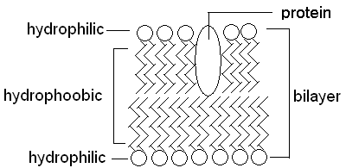

You may decide to complete your terms online. There are different programs / applications that are great tools for creating study tools. Please confirm your method beforehand.

Cards can be used on a daily basis to learn and review important concepts, as review for tests, and finally as study notes for the final exam. They may also prove useful as review for future university courses in Biology.

