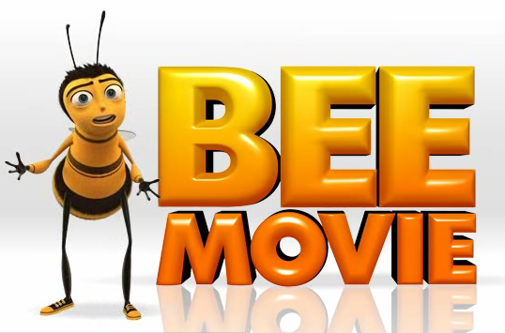
Bee Movie Worksheet
Name:
Date:

- In the Bee Movie, What are the known laws of aviation?(2 mark)

- How does Barry the Bee use the kind of determination that bees use to fly when following his dream?(2 marks)

- What is Barry Bee’s educational path in the Bee Movie?(3 marks)

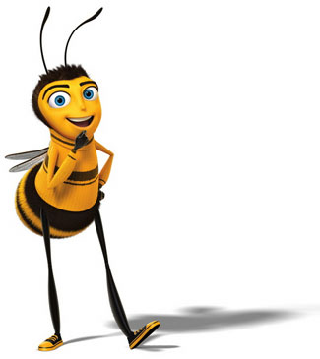

- One of the High Five Messages is to “align your allies”. Who are Barry Bee’s allies in the movie? (3 marks)

- In the Bee Movie what are the expectations of a bee when choosing a job?(2 marks) What is Barry bee’s reaction to this expectation? (2 marks) What were the other options that he explored?(2 marks)

- What happened in the movie for Barry to pursue the occupation of a lawyer? (3 marks)

- What are some of the different occupations that Barry the bee had throughout the movie? (3 marks)

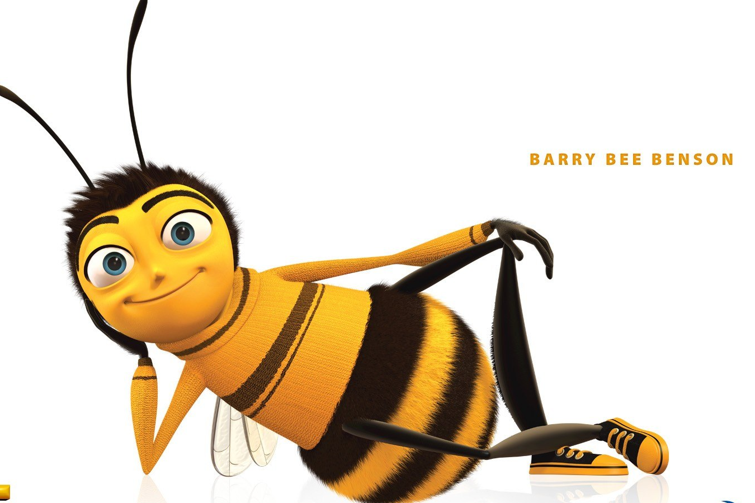
- Draw a line to match the character with their correct occupation in the Bee Movie.(7 marks)

Bee Larry King | Singer
Moose blood | Bee Killer
Mr. Montgomery | Interviewer
Ray Liotta | Florist
Vanessa | An actor
Bear | Lawyer
Sting | Blood Sucker and Lawyer

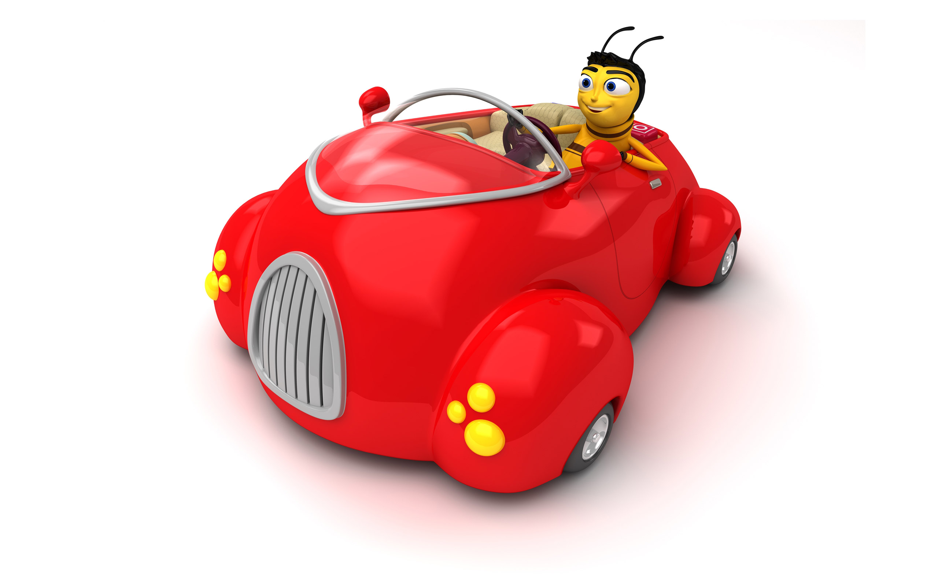
- “Jobs no matter how small if done right can make a big difference to everyone”. What happens in the Bee Movie when the bees that have never had a break in 27,000,000 years stop working? (2 marks)

- Skills can be classified as transferable and technical. Give examples of skills from each of the skill classifications that Barry used throughout the movie to make his journey successful? (4 marks)

Transferable:

Technical:

- What were 3 important messages you learned from the Bee Movie? (3 marks)



