Hockey Canada Skills Academy
2 vs. 1 + Goalie

Defensive Responsibilities

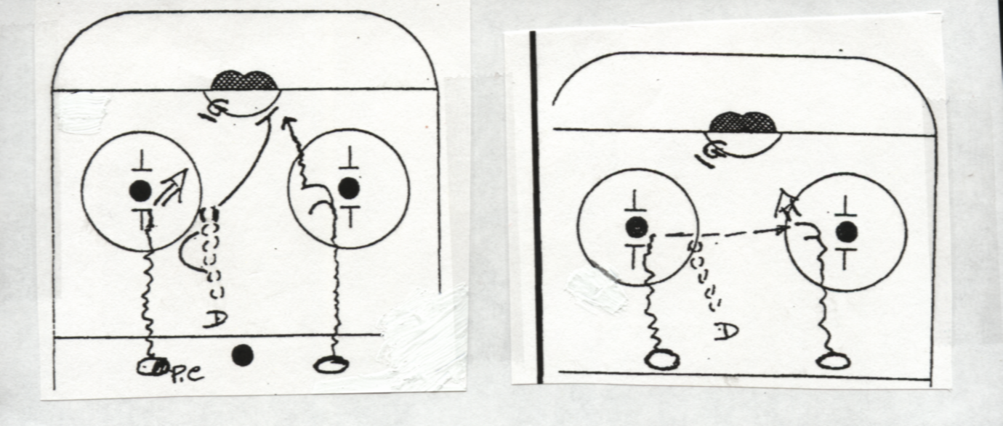
1. Goalie:
- Concentrate on puck carrier
- Cut the shooting angle safely
- If pass across is obvious (i.e. Puck carrier’s stick position) be ready to slide across
- * Be alert to good shooter who looks and fakes the pass, then shoots!

2. Defenseman:
- Start moving back with an overplay position on puck carrier. You are trying to move the puck carrier to poorest possible shooting angle.
- Use fake movement toward puck carrier (+ recover) to widen him out or to encourage him to shoot early or pass early.
- When Defenseman sees the puck carrier start to shoot, he leaves overplay position quickly to an inside rebounding position on open forward. Help goalie cover the rebound or play rebound to corner.
- * A 2nd option for the defenseman is to attack the puck carrier if:
- 1. The puck carrier has poor control (head down , or puck rolling)
- 2. Puck carrier always shoots (scouting) – never passes
- * You may have to slide block the pass across if:
- The puck carrier is too wide or deep to shoot effectively. Timing is crucial- you can’t go down too soon.
- Note: Know if the puck carrier is on his off-wing. If on off-wing, play him closer. (If he is on his off-wing, his shooting angle is better so play him closer.)

3. Forwards Responsibilities: Puck Carrier
- think shot as 1st priority. Allows you to concentrate on taking a good quality shot!
- Take the best possible angle that defense will give you.
- Read + feel defensemen’s position.
- Read the goalie’s position
- If defenseman overplays you too far, “look” shot (like you are going to shoot) and pass across to open man.
- If no defensive pressure, take best angle and quality shot and drive to net for rebound.
- If D. commits really early to open forward, you get extra time (almost like a penalty shot) so you can shoot or deke!
- If goalie challenges too far in anticipation of shot- fake the shot and go by on short side (with shot or deke) See picture below.
- If you don’t have a lot to shoot at and you don’t think you can get the pass across, think low wide shot, with the hope of a rebound for your teammate.

Support Forward
- Provides width to attack
- Don’t trail
- Must control skate and should be slightly behind puck carrier’s position laterally!
- If on off-wind, use open up technique to angle yourself so that you’ll be able to get the shot off quickly
- Get shot away quickly so goalie has trouble getting across and usually high shot will be best
- If puck carrier shoots, drive to net for rebound
- Remember not to get too deep too quickly + Never go past the net (unless puck is past the net!)
- 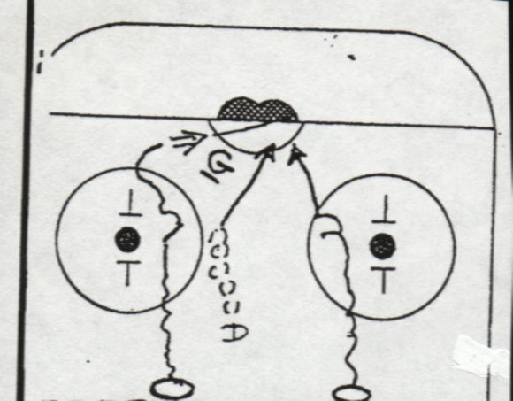Sometimes you will “drive skate” to post for hard pass from puck carrier. Tries to get behind D.

Defense Responsibility in Outside 2 on 1
Outside 2 on 1 (Delay mode)
- Favour puck carrier more (closer to 1 vs. 1)
- 1st Priority is to eliminate the “drive”
- Puck carrier slows down, (not driving), you can lay off more + change priority to making pass difficult, you would like the puck carrier to shoot from wide angle.
- You are delaying to buy time for 1st back checker.

