WEAPONS
This page is intended to provide a brief overview of the weapons used by the Canadian Expeditionary Force during the First World War
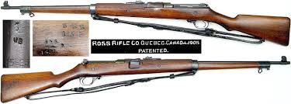 | Calibre ~ .303in  Capacity ~ 5  Rate of fire ~ approximately 10-15 r.p.m.  Weight ~ 9 pounds 12 ounces
Ross Rifle
Although extremely accurate the Ross was a poor combat weapon prone to jam during rapid fire (during combat soldiers would resort to kicking the bolt open) and if assembled incorrectly the bolt could be blown back into the shooter's face causing serious injury.
Canadian soldiers hated the Ross and were only too willing to grab a British Lee-Enfield rifle (usually from a dead British soldier) at the first opportunity. At the insistence of the British the Ross was withdrawn in 1916 to be replaced with the Lee-Enfield MK III. A small number were retained for sniping, a task for which their accuracy made them ideal. The rest, about 30,000 were eventually sold off as surplus. After abandoning the Ross rifle the Canadian government expropriated the plant located in Quebec City and paid Sir Charles Ross 2 million dollars.
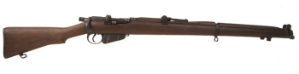 | Calibre ~ .303in  Capacity ~ 10  Rate of fire ~ approximately 12-15 r.p.m.  Length ~ 44.5in  Weight ~ 8 pounds 10.5 ounces
Lee-Enfield SMLE MK III
Arguably the best bolt action military rifle of all time its fast smooth action allowing 15 aimed shots per minute. Millions were produced and they served superbly thoroughly the world. The Lee-Enfield entered Canadian service in 1916 as a replacement for the Ross.
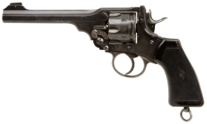 | Calibre ~ .455 in  Capacity ~ 6  Rate of fire ~ approximately 12-15 r.p.m.  Length ~ 11 in  Weight ~ 37 oz
Webley & Scott MK VI
First introduced in 1915 the Webley was the standard side arm of Canadian and British troops. Tough and reliable it gave excellent service and was manufactured in huge quantities. There was also an after market stock and bayonet that some officers purchased privately. It should be noted that Canadian and British troops carried a large variety of pistols and revolvers during the Great War the Webley MK VI being the most common. Some other side arms were the Colt New Service .455in , Webley & Scott MK V .455in, Colt Model 1911 .455in
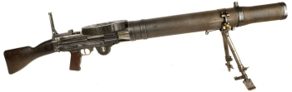 | Calibre ~ .303in  Capacity ~ 47  Rate of fire ~ 550 r.p.m.  Length ~ 50.5in  Weight ~ 27lb
Lewis Gun
Developed in 1910 the Lewis Light Machine Gun was adopted by the British Army in 1915 as a source of light automatic firepower that could be carried and operated by one man. By 1916 each infantry Battalion was equipped with 8 guns and by 1917 this had risen to 16, one for each platoon. Although somewhat delicate and prone to jam in the dirty conditions of trench warfare the Lewis was an effective weapon that continued to serve in huge numbers with British and Canadian troops throughout World War 1 and into the opening stages of World War 2. A lightened version was also used on aircraft.

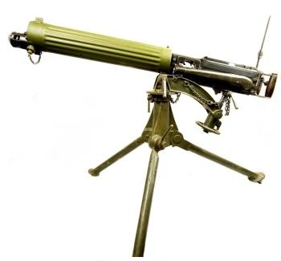 | Calibre ~ .303in  Capacity ~ 250 round cloth belt  Rate of fire ~ 500rpm  Length ~ 45.5in  Weight ~ 62lb
Vickers MK1
Named for the British company which manufactured it the Vickers was developed in 1912 as an improved version of the Maxim gun. Lighter and stronger than the Maxim the Vickers was still a heavy weapon by today's standards. At 62lb it required a crew of 6 men to carry the gun, its tripod and the water for its cooling jacket and a further 16 for the ammunition.
In 1915-1916 each Canadian infantry Battalion was entitled to 4 heavy machine guns either the colt or the Vickers. By 1917 the heavy machine guns belonged to the newly formed brigade machine gun companies. By 1918 each of the four Canadian divisions were equipped with no less than ninety six Vickers guns each. The Vickers could also be found mounted on armored vehicles and aircraft such as the Sopwith Camel. Extremely tough and reliable the Vickers was one of the best weapons of its class ever produced, a fact born out by the fact that it continued in military service until the 1960s.

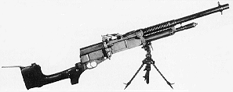 | Calibre ~ .303in  Capacity ~ 30 rounds  Rate of fire ~ 500rpm  Weight ~ 27lb
Gun, Machine Hotchkiss Mark I
The Hotchkiss was the classic French Machine Gun of World War One. Suffering from over-heating and ammunition problems it never the less served the French Army well. There were several different models made including the model 1914 and the model 1909 Portatif. Small numbers of the model 1909 were issued to Canadian and British Calvary units in 1916. In British service the gun was re-chambered for the .303in caliber cartridge and designated Gun , Machine, Hotchkiss Mark 1. It was also sold to the American Forces in .30 calibre upon their entry into the war.

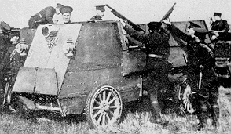 | Calibre ~ .30in  Length ~ 40.75in  Weight ~ 35lb
Colt-Browning M1895
In August 1914 Canada had but a handful of obsolete maxim machine guns. To remedy this situation Sir Sam Hughes ordered 50 colt model 1895 machine guns from the factory in the United States. Obsolete by 1914 standards the colt was never the less better than nothing. They were withdrawn in 1916 when supplies of the Vickers MK1 became available. The photo shows Colt machine guns mounted on Canadian armoured cars.

