Prime Ministers of Canada

Write the last name of the Prime Minister above each picture
Borden | Martin | Harper | King | Clark
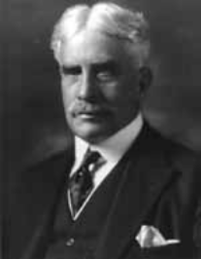 | 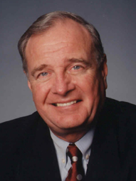 | 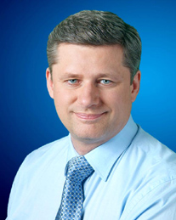 | 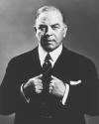 | 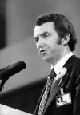
Chretien | Laurier | Macdonald | Campbell | Diefenbaker
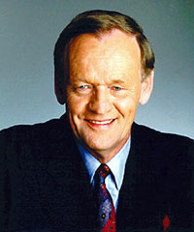 | 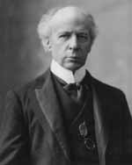 | 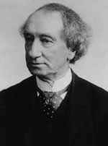 | 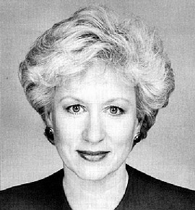 | 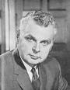
Trudeau | Bennett | Pearson | Mulroney | St. Laurent
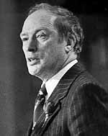 | 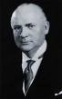 | 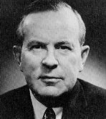 | 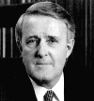 | 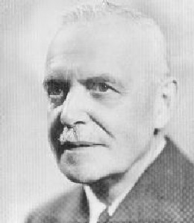
Mackenzie | Turner | Bowell | Thompson | Meighen
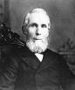 | 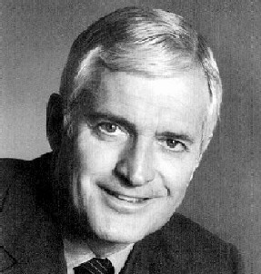 | 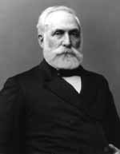 | 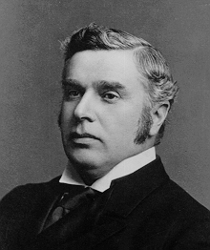 | 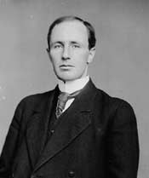
Abbott | Tupper | William Lyon Mackenzie King
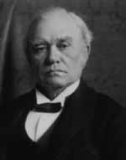 | 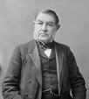 | Alexander Mackenzie  Sir Charles Tupper  Arthur Meighen  John Turner  Louis St. Laurent  Sir Mackenzie Bowell  Sir John Thompson  Joseph Clark | Brian Mulroney  Kim Campbell  Jean Chretien  Paul Martin, Jr.  Richard Bennett  Sir John Abbott  Pierre Elliott Trudeau  Stephen Harper | Sir John A. Macdonald  Sir Wilfrid Laurier  Sir Robert Borden  Lester B. Pearson  John Diefenbaker

