Handbook 10 Legal Drinking Age

Should Ontario change its legal drinking age to 18 like Quebec, Alberta and Manitoba or 21 like many US states?
Below are 2 articles published on this subject. Read the Articles and do further research before responding. Please try to think of all sides of this argument.

Should Ontario’s Legal Drinking Age Be Lowered?
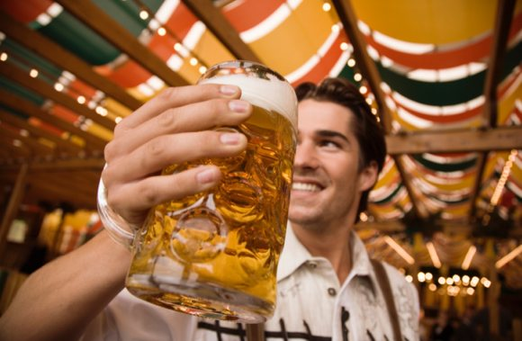
Some argue 18 is still too young to responsibly enjoy alcohol, while others feel it’s insulting to young adults.
Ontario’s legal drinking age is currently at 19-years-old. That puts the province’s legal drinkers one year older than its neighbours to the east and west (Quebec and Manitoba), but two years younger than their neighbours to the south (Michigan).
As the age floats in the middle, it is always a topic for heated discussion. Some argue 18 is still too young to responsibly enjoy alcohol, while others feel it’s insulting to young adults.
The topic was up for debate, as young authors Jaclyn Lytle (University of Ottawa) and Graham Briggs (University of Victoria) argued the issue in an article called, “Point/counterpoint: Should legal drinking ages be altered?”
“Beer, booze, liquor, spirits: Call it what you will — alcohol is one substance that is easily enjoyed, but even more effortlessly abused,” said Lytle.
“Blackouts, injury, alcohol poisoning, unprotected sex, increased instances of violence and impaired driving are all known and common consequences of binge drinking, a habit underage drinkers partake in far more often than their of-age counterparts according to the American National Institute on Alcohol Abuse and Alcoholism and Health Canada.”
On the other side of the bar, Briggs said 18-year-olds are already deemed old and responsible enough to be accorded full democratic rights.
“Eighteen-year-olds can also join the military. They can be trained to fight and kill in the name of their country. They can be sent to war. In the eyes of the military and the state that commands, 18-year-olds are adults.”

Author: Ryan Leclaire
Ryan has been writing for 7 years and has been featured in Chatelaine, Canadian Living and Cottage life.

CAMH report says Ontario should raise legal drinking age to 21
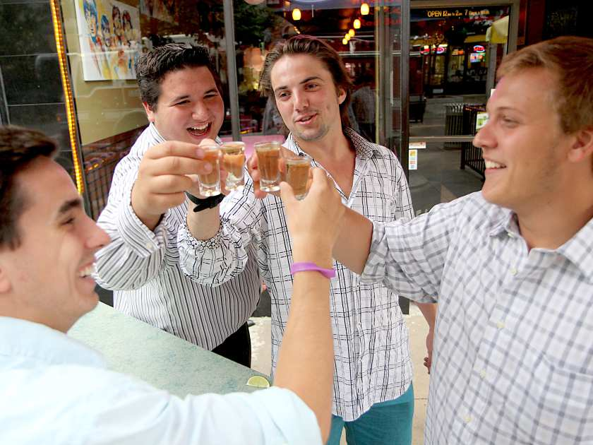
Tyler Van Norman, left, Anthony Savedes, Christian Michalik and Karsten Heppler toast shots of tequila in downtown Windsor on Saturday, June 22, 2013. The group from Michigan came to Windsor to celebrate Savedes and Van Norman's 19th birthdays. (REBECCA WRIGHT/ The Windsor Star)
A report that recommends Ontario raise its drinking age from 19 to 21 received a dismissive thumbs down from a group of Michigan friends who’d come to Windsor Saturday to celebrate two of them turning 19.
“I don’t agree with it at all. I think it stimulates the Canadian economy, especially Windsor because when you look at how many people come over once they turn 19, they put in so much money,” Christian Michalik, 20, said of recommendation from the Centre for Addiction and Mental Health, which contends raising the age to 21 would reduce alcohol abuse and the harm caused by alcohol. With Michigan’s minimum age of 21, Windsor has long been a destination for young Michigan partiers.
“When you look at the United States, you can go fight in a war, but you can’t drink a beer, which is absolutely ridiculous,” said Tyler Van Norman, who joined Michalik and agreed a 21-year-old legal drinking age doesn’t make sense.
The report suggests increasing the age to 21 could help reduce drinking and driving tragedies, delay the onset of drinking and ultimately keep youths safer.
“Alcohol is no ordinary commodity,” the report states. “It is imperative that Ontario continues to implement precautionary alcohol policies in order to reduce the harm and costs associated with alcohol use and to enhance the health and safety of Ontarians.”
Tayla Anderson, a manager at Honest Lawyer in downtown Windsor, said she sees a lot of 19-year-old Americans like Michailik and Van Norman partying at downtown bars on the weekend. But although they boost business, she said she would support increasing the legal age to 21.
“I just feel more comfortable serving a little bit of an older crowd,” said Anderson, adding most fights or other problems that occur in the bar involve patrons that are 19 or 20. “It’s just you feel more comfortable when there’s a little bit more maturity. Those two years definitely make a difference.”
Downtown Windsor Business Improvement Association chairman Larry Horwitz said if the minimum legal drinking age is increased to 21 there would be little impact on businesses in the city’s core.
“I don’t think it would affect our businesses that much,” said Horwitz. “I think that downtown is transforming itself. There’s very few bars that cater to people at a younger age.”
Horwitz said stricter passport laws that came into effect following 9/11 has deterred many Americans from coming to Windsor anyways.
“Many of the young people that age that come across don’t get passports and don’t really look at Windsor as that same destination that it was in the early 2000s,” said Horwitz.
With all the hustle and bustle of a typical Friday or Saturday night in Windsor’s downtown, raising the legal drinking age may equate to less noise.
But Downtown Residents Association president Mike Holdsworth said he’s never heard from people living in the city’s core complaining about the age of partiers.
“It’s never come up,” said Holdsworth. “It’s never been an issue.”
Mothers Against Drunk Driving Windsor and Essex County community leader Chaouki Hamka said while raising the age to 21 is not in MADD Canada’s policy, it’s something members would support if there was enough political and public interest.
“There’s been some science and research in the United States that has shown that raising the drinking age has saved lives,” said Hamka.
MADD U.S. reports more than 25,000 lives have been saved in the U.S. due to the 21-year-old minimum legal drinking age.
“The age limit for alcohol is based on research which shows that young people react differently to alcohol,” the MADD website states. “Teens get drunk twice as fast as adults, but have more trouble knowing when to stop. Teens naturally overdo it and binge more often than adults.”
The website further asserts “before the 21 minimum legal drinking age was implemented by all states, underage drunk drivers were involved in over twice as many fatal traffic crashes as today.”
Lisa Luttenegger, a 25-year-old from Chicago who was visiting Windsor Saturday to get away from the big city and watch the Stanley Cup finals, said she prefers the legal drinking age in the U.S. and agrees Ontario should follow suit.
“I think it’s really annoying when you go to a bar and maybe someone who just graduated high school could be there,” said Luttenegger. She added that those two years from 19 to 21 years old definitely make a difference when it comes to handling your alcohol more responsibly.
“I wouldn’t want to know myself at 19 drinking in a bar,” said Luttenegger with a laugh.
But Windsorites Emily D’Aloisio, 22, and her 19-year-old sister Ellen, who were headed to a downtown bar Saturday night, disagree with Luttenegger’s logic.
“I’m 19 and she’s 22 and we’re just as mature,” said Ellen.
“Those people who are going to make mistakes are going to make mistakes – it doesn’t matter the age,” said Emily. “If they’re going to be stupid, they’re going to be stupid whether they’re 19 or 21 – it doesn’t matter. And especially if there’s alcohol involved.”
Legal drinking age throughout Canada
Province | Legal age
Alberta | 18
British Columbia | 19
Manitoba | 18
New Brunswick | 19
Newfoundland and Labrador | 19
Northwest Territories | 19
Nova Scotia | 19
Nunavut | 19
Ontario | 19
Prince Edward Island | 19
Québec | 18
Saskatchewan | 19
Yukon | 19

This article was published in the Windsor Star
Published on: June 22, 2013 | Last Updated: June 22, 2013 9:11 PM EST

