Skill #5 Formal Body Paragraph
Applied Level Version

This chart shows the steps of logical writing so that selected quotations support an argument. Use only formal language (No You, I, We)

 | Anatomy of Paragraph | Example | Your version
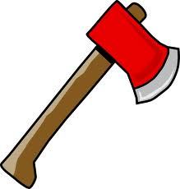 | Opening Sentence states your argument (The Hatchet) | Scout is resentful of Blacks who hold power.
 | Add a definition of the key word. | Being resentful means holding a grudge against someone.
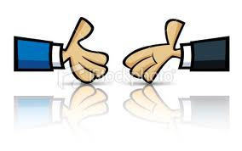 | Introduce the circumstances of the first quotation. (The Handshake) | Scout demonstrates her resentment of powerful Blacks, when arguing with Calpurnia. who had scolded her for having ridiculed Walter Cunningham’ s table manners.
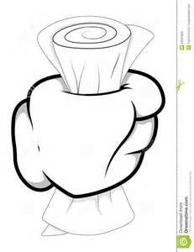 | Summarize the first scene/event  or  State the first quotation  (The Conversation) | She scolded Scout for making fun of Walter Cunningham when he poured a lot of syrup over his food. Scout was thinking that she will get back at Calpurnia for disciplining her.
 | Analyse the quotation, connecting it back to the argument.  (The Magnifying Glass) | Scout’s response to Calpurnia shows that she resents the power she has over her. She does not want to accept her discipline without fighting back.
 | Introduce the circumstances of the second quotation. (The Handshake)
Summarize the first scene/event
or
State the first quotation
(The Conversation)
Analyse the quotation, connecting it back to the argument.
(The Magnifying Glass)
 | Introduce the circumstances of the third quotation. (The Handshake)
Summarize the first scene/event
or
State the first quotation
(The Conversation)
Analyse the quotation, connecting it back to the argument.
(The Magnifying Glass)
 | Concluding sentence for paragraph. List all the examples you used. | Scout’s response to Calpurnia’s disciplining, her unflattering description of Calpurnia and her criticism of her double life illustrate her resentment, because she fails to accept the power of the Black woman in her life.

