Caribou – Oct 2018 – Grade 5/6

Contest Solutions

At most how many students can sit in a row of 25 chairs, if seated students must be separated by at least two empty chairs?
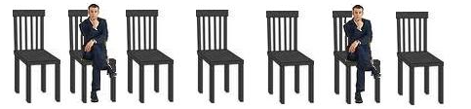
- 9
- 10
- 11
- 12
- 13
- 14
- 15

Hide Solution
- To maximize the number of students that can sit in these chairs, it is useful to think where the leftmost student should sit. Having a student sit on the leftmost chair is definitely not worse than having him/her sitting on any other chair because sitting on the very left means that maximal space is available on the right of that student. Having one or two free seats to the left of the student does not allow another student to sit on the left but may reduce the number of students sitting on the right.
Because of the left ↔ right symmetry of the question, we equally could start by placing a student on the rightmost chair and get the same solution.
1. Solution
So, when the first person sits in the leftmost chair, the next person should sit in the 4th chair (because we should leave at least 2 chairs empty) and the other students would sit on the 7th, 10th, 13th, 16th, 19th, 22nd, 25th chairs. In total 9 students will get a seat.
2. Solution
If the number c of chairs is large then counting the occupied ones would be too much effort. We can compute that number s of students on chairs by
∙ subtracting 1 from c for the leftmost chair which will be occupied,
∙ dividing the remaining number c−1 of chairs by 3 (2 free chairs + the next occupied chair = 3 chairs), and
∙ adding 1 to it for the leftmost student.
In the case of this question we get
(25−1)/3+1 = 24/3+1 = 8+1 = 9.
If c−1 is not divisible by 3 then we only take the integer part from this division. For example, if there would be 27 chairs then (27−1)/3 = 8 reminder 2 so we would use 8 and by adding 1 for the leftmost student, we would still get only 9 occupied seats which is correct.
A square is NOT
- a special type of parallelogram
- a special type of polygon
- a special type of rectangle
- made from equal length sides
- made from sides of different length
- 4-sided
- composed of 90º angles

Hide Solution
- A square is a special type of parallelogram, polygon, rectangle and it has 4 equally long sides and four 90º angles. Therefore, it is not made from sides of different lengths.
Tom has 2 blue and 3 red toy cars. Eric has 1 blue and 2 yellow cars. When they run down a track, the blue cars go twice as far as the red cars and the yellow go three times as far as the red cars. If the blue cars go 4 m (metres) each, what is the total distance travelled by all the cars?
- 24
- 26
- 30
- 32
- 36
- 40
- 44

Hide Solution
- There are (2+1)=3 blue cars, 3 red cars and 2 yellow cars in total.
If the blue cars go 4 m each, the red cars go half this distance. Therefore the red cars go 4 m / 2 = 2 m each. The yellow cars go three times as far as the red cars, therefore the yellow cars go 3 × 2 m = 6 m each.
Red cars: 3 × 2 m = 6 m
Blue cars: 3 × 4 m = 12 m
Yellow cars: 2 × 6 m = 12m
The total distance travelled by all the cars is 6 m + 12 m + 12 m = 30 m.
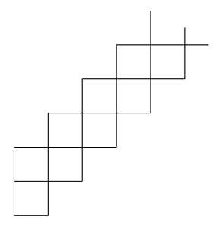
A shape consisting of 2018 squares is made by continuing the pattern shown above. Each small square has a side length of 2 cm. What is the length, in cm, of the perimeter of the whole shape?
- 2018
- 2020
- 4036
- 4038
- 8072
- 8076
- 8078

Hide Solution
- Notice that each square has 2 sides contributing to the perimeter of the shape except for the first square, and by symmetry, the last square which contribute 3 sides to the perimeter. This means the perimeter is made up of (2018−2) × 2 + 2 × 3 = 4032 + 6 = 4038 square edges that are each 2 cm in length. Thus the perimeter of the shape is 4038 × 2 cm = 8076 cm.
If a ♥ b = 2×a − b, what is the value of 2 ♥( 3 ♥ 5 )?
- 2
- 3
- 4
- 5
- 6
- 7
- 8

Hide Solution
- At first the computation in brackets needs to be done. We get
3 ♥ 5 = 2×3 − 5 = 6 − 5 = 1.
Now we can calculate
2 ♥ 1 = 2×2 − 1 = 4 − 1 = 3. Therefore
2 ♥ (3 ♥ 5) = 3.
Steve plants twelve trees every thirty minutes. If he continues planting at the same rate, how long will it take him to plant 240 trees?
- 1 h
- 3 h
- 5 h
- 8 h
- 10 h
- 12 h
- 14 h

Hide Solution
- 1. Solution
Steve plants twelve trees every thirty minutes. Let's find how much time he needs for 240 trees.
Because 240 / 12 = 20, he needs 20 × 30 minutes = 600 minutes.
So, in order to plant 240 trees, Steve will need 600 minutes = 10 hours.
2. Solution
If it takes 30 min = 1/2 hour to plant 12 trees then in one hour 24 trees can be planted so it takes 10 hours to plant 10×24 = 240 trees.
What is the perimeter of this shape ?
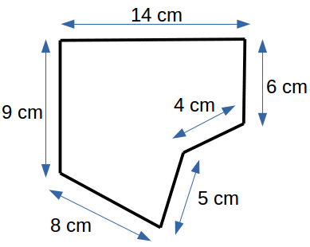
- 28
- 42
- 35
- 46
- 38
- 26
- 39

Hide Solution
- The perimeter of a shape is the length of its surrounding line. In this case the length is 14 cm + 6 cm + 4 cm + 5 cm + 8 cm + 9 cm = 46 cm.
Nicu chooses a number, adds 1 to it, then subtracts 2 from the result, then multiplies the new result by 3, then divides the outcome by 4 and finally obtains 6. What was the number chosen at the beginning?
- 0
- 1
- 3
- 6
- 8
- 9
- 10

Hide Solution
- In order to solve this question, it is a good strategy to start from the number that Nicu obtained at the end and go backwards. To do this we will replace + by − and − by + and replace × by / and / by ×:
If he obtains 6 when dividing by 4, the divided number was 6 × 4 = 24.
Then, if he gets 24 when multiplying by 3, the number multiplied to was 24 / 3 = 8.
If he obtains the 8 when subtracting 2, then he started with 10 because 8 + 2 = 10.
Lastly, if the result is 10 when adding 1, then the original number was 10 − 1 = 9.
The date 01/03/05 (March 1, 2005) is the first of the 21st Century in which the date contains three consecutive odd numbers in ascending (increasing) order. How many such dates are there in the 21st century (in the form DD/MM/YY)?
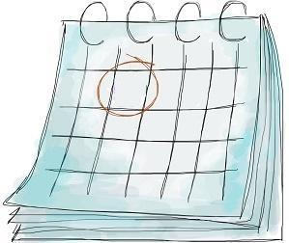
- 3
- 5
- 7
- 16
- 21
- 36
- 48

Hide Solution
- There are 100 different years in the 21st century (00-99), each having 12 months (Jan-Dec). Each odd month has 30-31 days in it. Since we are only looking for consecutive odd numbers in ascending order, we can add 2 to each the day, month and year starting with 01/03/05 until we run out of possibilities.
Since there is a smaller number of months than days and years, this will occur after we run out of odd months. Thus, there are 5 such dates: 01/03/05, 03/05/07, 05/07/09, 07/09/11, and 09/11/13.
A school has two types of rooms: rooms for smaller classes with 2 windows and rooms for bigger classes with 3 windows. There are 58 windows in the school, and 25 rooms. How many rooms are for smaller classes?
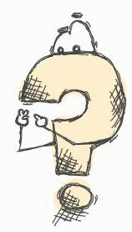
- 6
- 7
- 8
- 9
- 10
- 11
- 17

Hide Solution
- 1. Solution
Let us consider the case that all the 25 rooms are for smaller classes. Then the school would have 25×2 = 50 windows. However, there are 58 windows so in total 58−50 = 8 windows more.
Exchanging a small room with a bigger room requires 3−2=1 more window per room.
That means the 8 extra windows belong to 8/1 = 8 bigger rooms. Because there are in total 25 rooms, there are 25 − 8 = 17 rooms for smaller classes.
2. Solution
Let
x indicate the number of rooms for smaller classes
y indicate the number of rooms for bigger classes.
If there are in total 25 rooms, then x + y = 25.
If there are in total 58 windows then 2x + 3y = 58
Now, in order to deduce the value of y, let us multiply the first equation by −2 and then add these equations. That is,
−2x − 2y = −50
2x + 3y = 58
+____________
y = 8 (rooms for bigger classes)
Hence, the number of rooms for smaller classes is 25 − 8 = 17.

LIGHTS©
Clicking a box changes the lighting in that box and all neighbouring boxes, from dark to light or light to dark.
>> You win if all lights are on. <<

Hide Solution
- Let us label the columns A, B, C, D, and E from left to right and label the rows 1, 2, 3, 4, and 5 from top to bottom. By clicking squares: A1, E1, E5, A5, C2, and C4 all lights will be ON.
Explanation:
The pattern of lights is symmetric with respect to the vertical line in the middle and the horizontal line in the middle. Therefore clicks should also be symmetric with respect to these two lines.
Lights on the horizontal middle line are all ON. They should therefore not be switched because by switching symmetric neighbouring lights the lights on the symmetry line would be switched an even number of times more and thus stay OFF.
On the other hand, lights on the vertical symmetry axis should be switched. If we start, for example with C2 and by symmetry also C4 then we quickly see that we then only have to switch the 4 corners. As described under 'Some food for thought', solutions are not unique if there is a cycle. For example, if we start with C1 and C5 then we see that A2 and by horizontal symmetry also A4 and by vertical symmetry also E2 and E4 need to be switched providing another solution.
Mr. Young gives his 4 children 50 Cents for each year of their age so that they can donate that money to their favourite charity in their name. David is 13, Anne is 11, Michael is 7 and Adam is 5 years old. How much money will the children donate in total?
HINT (for participants from outside North America): 1 Dollar = 100 Cents.
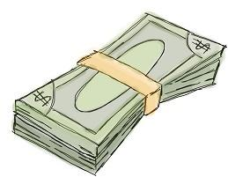
- 12 Dollars
- 13 Dollars
- 15 Dollars
- 16 Dollars
- 18 Dollars
- 20 Dollars
- 22 Dollars

Hide Solution
- The total money for donation can be calculated by multiplying the age of each child by 50 and then adding up the 4 numbers.
However, a faster way is to add first all ages and then to multiply the sum by 50. In this way we only need one multiplication, not four multiplications.
The sum of their ages is 13+11+7+5 = 36 and therefore the children donate 36 × 50 Cent = 1800 Cent = 18 Dollar. We find this value also by seeing that 50 Cent = 1/2 Dollar. So 36 / 2 = 18 Dollars were donated.
How many points do the shapes in the table have in total?
For example, has 4 points.
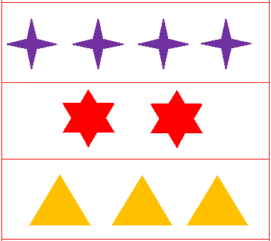
- 33
- 34
- 35
- 36
- 37
- 38
- 39

Hide Solution
- In the top row there are 4 purple stars each of which has 4 points.
So, there are 4 × 4 = 16 points in the first row.
In the second row there are 2 stars each of which has 6 points.
So, there are 2 × 6 = 12 points in the second row.
In the third row there are 3 triangles each of which has 3 points.
So, there are 3 × 3 = 9 points in the third row.
Therefore, there are 16 + 12 + 9 = 37 points in total.
Find a pattern in the following sequence of numbers: 12, 16, 20, 24, 28, ... . What is the next number?
- 31
- 32
- 33
- 34
- 35
- 36
- 37

Hide Solution
- When searching for a pattern in a sequence of numbers then the first thing to check is whether the numbers increase or decrease at a constant rate. This is the case in this question. The rate of increase is found by subtracting two consecutive numbers, for example, 16−12 = 4 or 20−16 = 4 or 24−20 = 4 or 28−24 = 4.
So, the next number must be 28 + 4 = 32.
The first time after midnight when all digits of a digital clock are different and even is 0:24 am. What is the last time before noon when all digits on the clock are different and even?
- 10:48 am
- 8:64 am
- 8:48 am
- 8:46 am
- 8:42 am
- 6:48 am
- 6:46 am

Hide Solution
- For the question we can only use digits 0, 2, 4, 6, 8 as even digits.
To have a time as late as possible, we will select biggest digits first when filling up positions from left to right and we will use the digits once.
The number 10 is even but it consists of the two digits 1 and 0 and the digit 1 is not even, so option a is wrong.
To start, we should use the biggest digit 8 for the hour. Then, we can not use 6 for the first digit of minutes because an hour has 60 minutes, so the next two digits must make up a number less than 60.
Therefore, we will use the next biggest even digit which is 4 and then we can use 6 for the ones digit of minutes.
Hence, the latest time before noon is 8:46 am.
Alice has forgotten the pin number of her credit card. She remembers that
1) It is a 4 digit number.
2) There are no repeated digits.
3) It is an even number.
4) It is the birthday of her dog (DD/MM)
What could be her pin number?
- 3102
- 1307
- 2321
- 2082
- 1604
- 418
- 1201

Hide Solution
- Let us go through the options. To start with, the password is is a 4 digit number and this directly eliminates option f.
Next, the password is an even number. This implies that the unit digit must be 0,2,4,6, or 8, elminating options b, c and g.
Now we have options a, d and e.
Then, the password does not include repeated digits, eliminating option d. So, we have options a and e left.
Then, because it is the birthday of her dog (DD/MM), we should check the numbers whether first 2 digits are proper for a day while last 2 digits are proper for a month. This eliminates option a because we do not have 31th day in February.
Therefore, the pin number is 1604.
Maria has a number of lollipops. After she offers each of her friends 4 lollipops (all accepted the offer ☺), Maria is left with 3 lollipops. Which of the following can be the number of lollipops that Maria had initially?
- 26
- 28
- 32
- 33
- 37
- 39
- 41

Hide Solution
- The number of lollipops that she handed out must be divisible by 4 because each one of her friends got exactly 4 lollipops. So, if we subtract 3 lollipops (which were left over) from the original number then the remaining number must be a multiple of 4. We get
Option a) 26−3=23 is not divisible by 4
Option b) 28−3=25 is not divisible by 4
Option c) 32−3=29 is not divisible by 4
Option d) 33−3=30 is not divisible by 4
Option e) 37−3=34 is not divisible by 4
Option f) 39−3=36 is divisible by 4
Option g) 41−3=38 is not divisible by 4
Therefore from the option values only 39 is a possible number of lollipops that Maria had initially.
At the Yellow Star Taxi company Sandra is a receptionist and Dave is a driver. Not including Sandra there are 4 receptionists. Not including Dave, there are 21 drivers employed. How many receptionists and drivers in total are employed by the taxi company?
- 5
- 21
- 22
- 25
- 26
- 27
- 28

Hide Solution
- Not including Sandra, there are 4 receptionists ⇒ there are 4+1 = 5 receptionists employed.
Not including Dave, there are 21 drivers ⇒ there are 21+1 = 22 drivers employed.
To get the total number of employed receptionists and drivers we have to add 5 + 22 = 27.

