Caribou – Oct 2018 – Grade 3/4

Contest Solutions

At most how many students can sit in a row of 25 chairs, if seated students must be separated by at least two empty chairs?
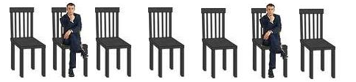
- 9
- 10
- 11
- 12
- 13
- 14
- 15

Hide Solution
- To maximize the number of students that can sit in these chairs, it is useful to think where the leftmost student should sit. Having a student sit on the leftmost chair is definitely not worse than having him/her sitting on any other chair because sitting on the very left means that maximal space is available on the right of that student. Having one or two free seats to the left of the student does not allow another student to sit on the left but may reduce the number of students sitting on the right.
Because of the left ↔ right symmetry of the question, we equally could start by placing a student on the rightmost chair and get the same solution.
1. Solution
So, when the first person sits in the leftmost chair, the next person should sit in the 4th chair (because we should leave at least 2 chairs empty) and the other students would sit on the 7th, 10th, 13th, 16th, 19th, 22nd, 25th chairs. In total 9 students will get a seat.
2. Solution
If the number c of chairs is large then counting the occupied ones would be too much effort. We can compute that number s of students on chairs by
∙ subtracting 1 from c for the leftmost chair which will be occupied,
∙ dividing the remaining number c−1 of chairs by 3 (2 free chairs + the next occupied chair = 3 chairs), and
∙ adding 1 to it for the leftmost student.
In the case of this question we get
(25−1)/3+1 = 24/3+1 = 8+1 = 9.
If c−1 is not divisible by 3 then we only take the integer part from this division. For example, if there would be 27 chairs then (27−1)/3 = 8 reminder 2 so we would use 8 and by adding 1 for the leftmost student, we would still get only 9 occupied seats which is correct.
Tom has 2 blue and 3 red toy cars. Eric has 1 blue and 2 yellow cars. When they run down a track, the blue cars go twice as far as the red cars and the yellow go three times as far as the red cars. If the blue cars go 4 m (metres) each, what is the total distance travelled by all the cars?
- 24
- 26
- 30
- 32
- 36
- 40
- 44

Hide Solution
- There are (2+1)=3 blue cars, 3 red cars and 2 yellow cars in total.
If the blue cars go 4 m each, the red cars go half this distance. Therefore the red cars go 4 m / 2 = 2 m each. The yellow cars go three times as far as the red cars, therefore the yellow cars go 3 × 2 m = 6 m each.
Red cars: 3 × 2 m = 6 m
Blue cars: 3 × 4 m = 12 m
Yellow cars: 2 × 6 m = 12m
The total distance travelled by all the cars is 6 m + 12 m + 12 m = 30 m.
What is the perimeter of this shape ?
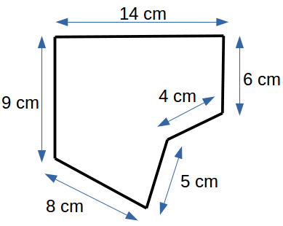
- 28
- 42
- 35
- 46
- 38
- 26
- 39

Hide Solution
- The perimeter of a shape is the length of its surrounding line. In this case the length is 14 cm + 6 cm + 4 cm + 5 cm + 8 cm + 9 cm = 46 cm.
Nicu chooses a number, adds 1 to it, then subtracts 2 from the result, then multiplies the new result by 3, then divides the outcome by 4 and finally obtains 6. What was the number chosen at the beginning?
- 0
- 1
- 3
- 6
- 8
- 9
- 10

Hide Solution
- In order to solve this question, it is a good strategy to start from the number that Nicu obtained at the end and go backwards. To do this we will replace + by − and − by + and replace × by / and / by ×:
If he obtains 6 when dividing by 4, the divided number was 6 × 4 = 24.
Then, if he gets 24 when multiplying by 3, the number multiplied to was 24 / 3 = 8.
If he obtains the 8 when subtracting 2, then he started with 10 because 8 + 2 = 10.
Lastly, if the result is 10 when adding 1, then the original number was 10 − 1 = 9.

LIGHTS©
Clicking a box changes the lighting in that box and all neighbouring boxes, from dark to light or light to dark.
>> You win if all lights are on. <<

Hide Solution
- Let us label the columns A, B, C, D, and E from left to right and label the rows 1, 2, 3, 4, and 5 from top to bottom. Clicking squares: A5, B4, C3, D3, and C2 in any order will turn all lights ON.
Explanation:
Because the pattern of lights in this question is symmetric with respect to the diagonal from the lower left corner to the upper right corner, the sequence of clicks should also be symmetric with respect to this diagonal.
If any light is OFF on this diagonal then this light needs to be clicked. If one would only click a neighbouring light then the other neighbouring light symmetric to the diagonal should also be clicked and then the light on the diagonal would be switched twice and stay OFF. This means lights A5, B4, C3 need to be switched.
One then easily sees that in addition lights D3 and C2 need to be switched as well.
Maria has a box with 20 lollipops. After she offers each of her friends 3 lollipops (all accepted the offer ☺), Maria is left with 2 lollipops. How many of Maria's friends received lollipops?
- 3
- 4
- 5
- 6
- 7
- 8
- 9

Hide Solution
- If 2 lollipops are left from 20 lollipops, it means that 20 − 2 = 18 lollipops were offered to the friends.
Then, if each friend took 3 lollipops, we can find the number of friends as 18 / 3 = 6 friends.
How many points do the shapes in the table have in total?
For example, has 4 points.
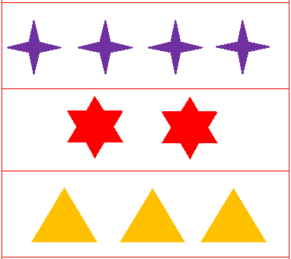
- 33
- 34
- 35
- 36
- 37
- 38
- 39

Hide Solution
- In the top row there are 4 purple stars each of which has 4 points.
So, there are 4 × 4 = 16 points in the first row.
In the second row there are 2 stars each of which has 6 points.
So, there are 2 × 6 = 12 points in the second row.
In the third row there are 3 triangles each of which has 3 points.
So, there are 3 × 3 = 9 points in the third row.
Therefore, there are 16 + 12 + 9 = 37 points in total.
How many triangles are shown below?
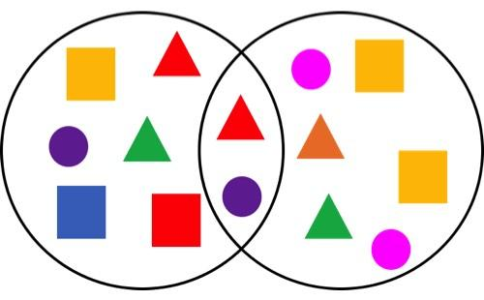
- 1
- 2
- 3
- 4
- 5
- 6
- 7

Hide Solution
- A triangle is a shape with 3 corners. There are 5 shapes with 3 corners, so there are 5 triangles.
Find a pattern in the following sequence of numbers: 12, 16, 20, 24, 28, ... . What is the next number?
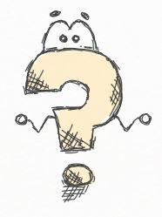
- 31
- 32
- 33
- 34
- 35
- 36
- 37

Hide Solution
- When searching for a pattern in a sequence of numbers then the first thing to check is whether the numbers increase or decrease at a constant rate. This is the case in this question. The rate of increase is found by subtracting two consecutive numbers, for example, 16−12 = 4 or 20−16 = 4 or 24−20 = 4 or 28−24 = 4.
So, the next number must be 28 + 4 = 32.
The first time after midnight when all digits of a digital clock are different and even is 0:24 am. What is the last time before noon when all digits on the clock are different and even?
- 10:48 am
- 8:64 am
- 8:48 am
- 8:46 am
- 8:42 am
- 6:48 am
- 6:46 am

Hide Solution
- For the question we can only use digits 0, 2, 4, 6, 8 as even digits.
To have a time as late as possible, we will select biggest digits first when filling up positions from left to right and we will use the digits once.
The number 10 is even but it consists of the two digits 1 and 0 and the digit 1 is not even, so option a is wrong.
To start, we should use the biggest digit 8 for the hour. Then, we can not use 6 for the first digit of minutes because an hour has 60 minutes, so the next two digits must make up a number less than 60.
Therefore, we will use the next biggest even digit which is 4 and then we can use 6 for the ones digit of minutes.
Hence, the latest time before noon is 8:46 am.
How many cats should be drawn on the right hand side of '=' to make it a correct statement?
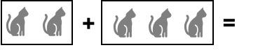
- 3
- 4
- 5
- 6
- 1
- 2
- 7

Hide Solution
- The '+' sign means that we need to add the two numbers of cats. We need to add 2 and 3 giving 5. We also could simply count all cats on the left and would get again 5.
Alice has forgotten the pin number of her credit card. She remembers that
1) It is a 4 digit number.
2) There are no repeated digits.
3) It is an even number.
4) It is the birthday of her dog (DD/MM)
What could be her pin number?
- 3102
- 1307
- 2321
- 2082
- 1604
- 418
- 1201

Hide Solution
- Let us go through the options. To start with, the password is is a 4 digit number and this directly eliminates option f.
Next, the password is an even number. This implies that the unit digit must be 0,2,4,6, or 8, elminating options b, c and g.
Now we have options a, d and e.
Then, the password does not include repeated digits, eliminating option d. So, we have options a and e left.
Then, because it is the birthday of her dog (DD/MM), we should check the numbers whether first 2 digits are proper for a day while last 2 digits are proper for a month. This eliminates option a because we do not have 31th day in February.
Therefore, the pin number is 1604.

