Released Assessment Questions, 2015
Grade 9 Assessment of Mathematics • Academic
For Use with Assistive Technology
Education Quality and Accountability Office, 2 Carlton Street, Suite 1200, Toronto ON M5B 2M9 Telephone: 1-888-327-7377 Web site: www.eqao.com © 2015 Queen’s Printer for Ontario.

Listen as your teacher reads the instructions. Some key points are listed below.
Make sure you have the Formula Sheet for reference.
The diagrams in this booklet are not all drawn to scale.

Answering Multiple-Choice Questions
Answer all multiple-choice questions. If you fill in more than one answer to a question, or leave a question blank, the question will be scored zero. Incorrect answers will also be scored zero.
Answering Open-Response Questions
Do all of your work for each question in the space provided for the question only.
Write your solutions, including all calculations, clearly and completely.

ATTENTION:
The format of this document differs from that of the actual assessment booklets, as the questions are sorted by strand.
There are more multiple-choice and open-response questions in this document than in a regular booklet.

You are now ready to start.
Multiple-Choice
1 A rectangle is divided into 5 equal sections as pictured below.
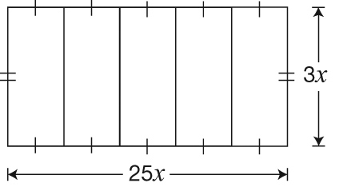

Which of the following represents the area of one section?
a 8x
b 8x²
c 15x
d 15x²

2 The table below contains five expressions.
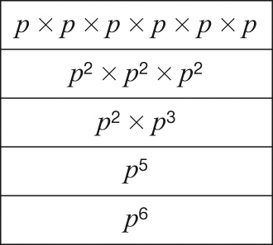

How many of these expressions are equivalent to (p²)³?
a 1
b 2
c 3
d 4

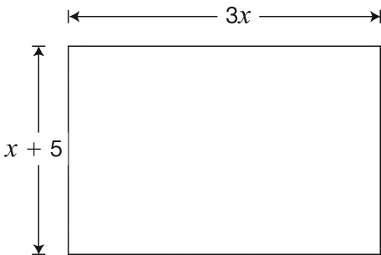
3 A rectangle is shown below with algebraic expressions for its length and width in centimetres.

Which expression represents the area of the rectangle in cm²?
a 4x + 5
b 8x + 10
c 3x² + 5
d 3x² + 15x

4 What is the solution to the equation below?
x – 4 = 20
a x = 12
b x = 16
c x = 24
d x = 36

5 Mia sells T-shirts from a booth at a market. She pays $30 to rent the booth. Each T-shirt costs her $1.50, and she sells them for $7.50 each.
Her goal is to make $200 after she pays for the booth and the T-shirts.
What is the minimum number of T-shirts Mia must sell to reach her goal?
a 27
b 29
c 34
d 39

6 Joanne drives for 2.5 hours at a constant speed and travels 250 km.
François drives at a constant speed exactly 10 km/h less than Joanne’s speed.
Which point on the graph below could represent the distance travelled and time spent travelling for François?
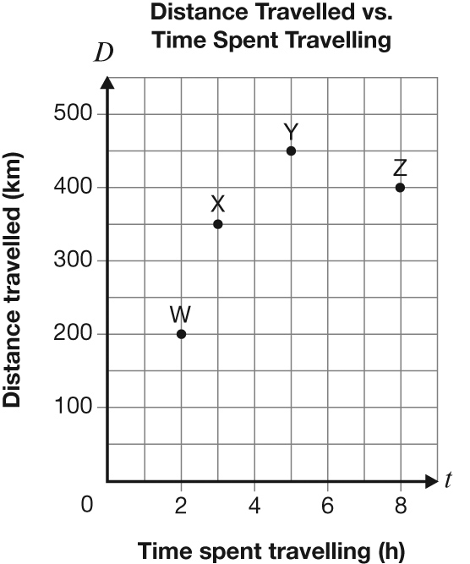

a Z
b Y
c X
d W
7 Which of the following shows information from a linear relation between C and n?
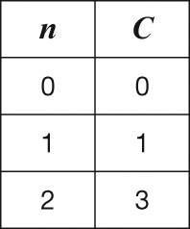
a

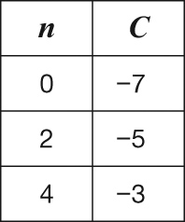
b

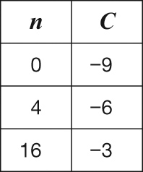
c

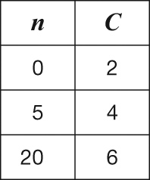
d

8 The total cost of yearbooks for a school is made up of a $375 set-up fee and $25 for
each yearbook purchased.
There is a linear relationship between the total cost and the number of yearbooks purchased.
What type of variation is this relationship, and what is its initial value?
a direct variation, $375
b direct variation, $25
c partial variation, $375
d partial variation, $25

9 A company ships CDs in crates of equal size. The graph below shows the relationship between the total mass of a crate and the number of CDs it contains.
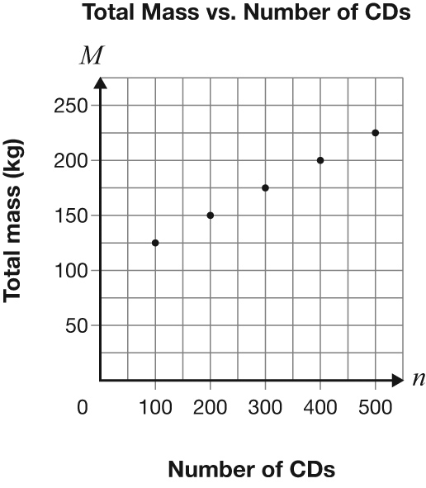

Which of the following equations represents the relationship between the total mass of a crate, M, and the number of CDs it contains, n?
a M = 0.25n + 100
b M = 4n + 100
c M = 0.25n + 125
d M = 4n + 125

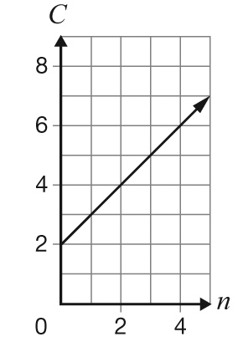
10 A relationship is represented by the following graph.

Which equation represents this relationship?
a C = n + 2
b C = n + 1
c C = 2n + 2
d C = 2n + 1

11 A local band pays $5000 to record its first album and $0.15 for each CD made.
The band pays $7000 to record its second album and $0.10 for each CD made.
How will the graph of the relationship between the total cost and the number of CDs made for the second album differ from the graph for the first album?
The graph of the line for the second album will start
a lower on the vertical axis and be steeper.
b higher on the vertical axis and be steeper.
c lower on the vertical axis and be less steep.
d higher on the vertical axis and be less steep.

Open-Response
12 More Snacks, Please!
Raisins and sunflower seeds are sold together in packages of 250 g. The ratio of the mass of raisins to the mass of sunflower seeds is 3 to 5.
Determine the mass of raisins in a package.
Show your work.
13 Getting Fit
Maddie enrols in a fitness program. Her total cost is made up of a sign-up fee and a cost per class.
The table below shows information about her total cost, C, in dollars, when she attends n classes.
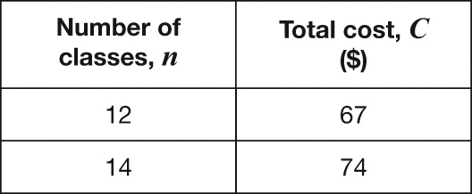

What is the sign-up fee?
Sign-up fee: _______________________________
Show your work.

Is the relationship between the number of classes Maddie attends and her total cost a partial variation or direct variation?
Circle one: Partial variation Direct variation
Justify your answer.

14 Kenny’s Big Adventure
The following graph represents the relationship between Kenny’s distance from home on a bike ride and time.
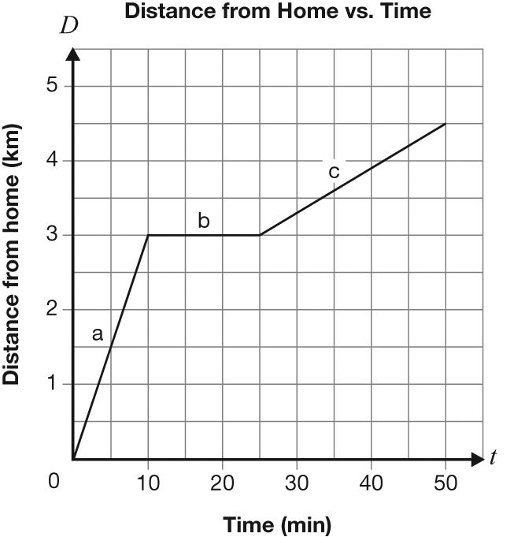

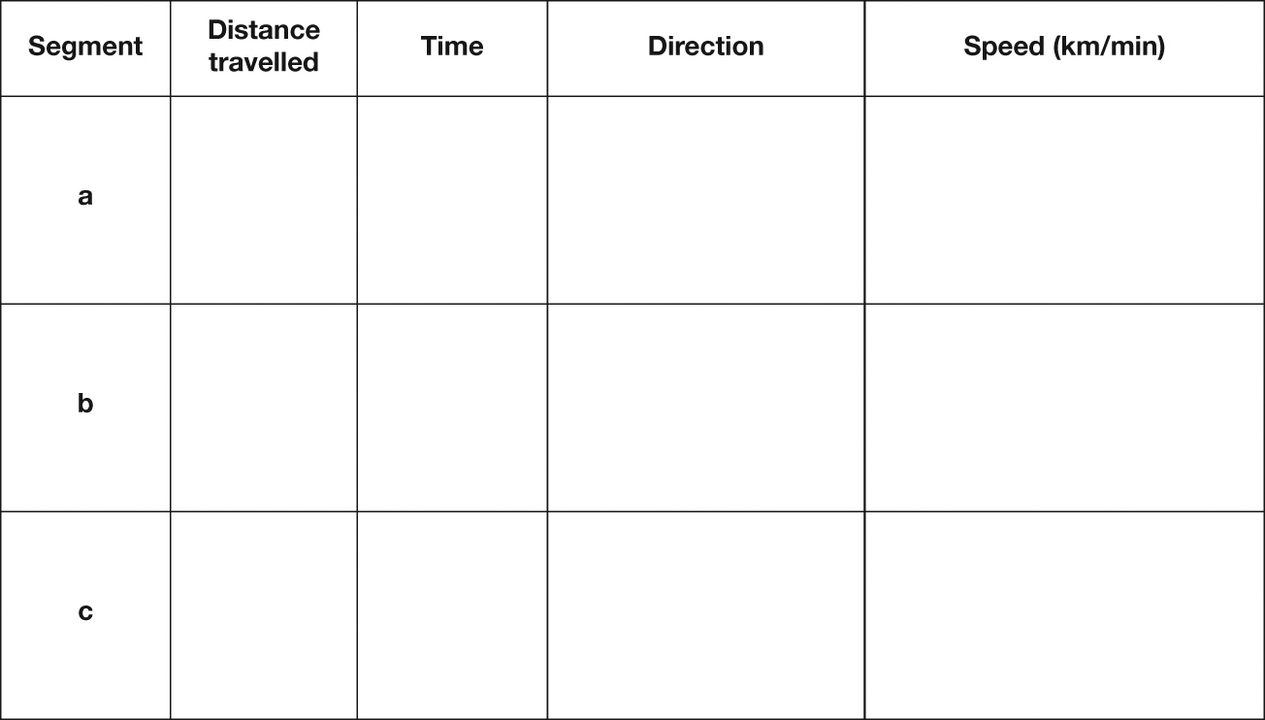
Describe the 3 segments of Kenny’s ride. Include information about distance travelled, time, direction and speed, in km/min, for each segment.

15 Comparing Relationships
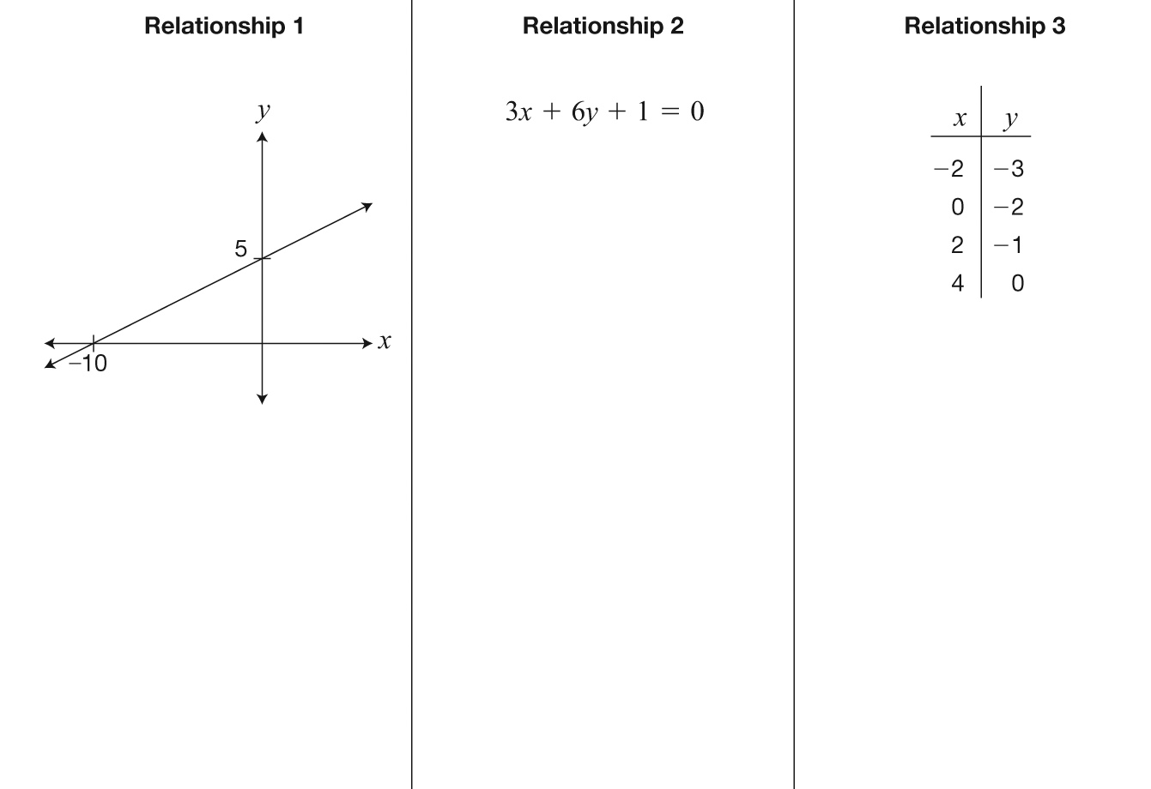
Information about three linear relationships is given below.

Circle the relationships that have the same rate of change.
Justify your answer. Include information about all three relationships.
16 Making Equations!
Determine the equation of the line that has the same y-intercept as 2x + y + 6 = 0 and is
perpendicular to the line shown on the grid.
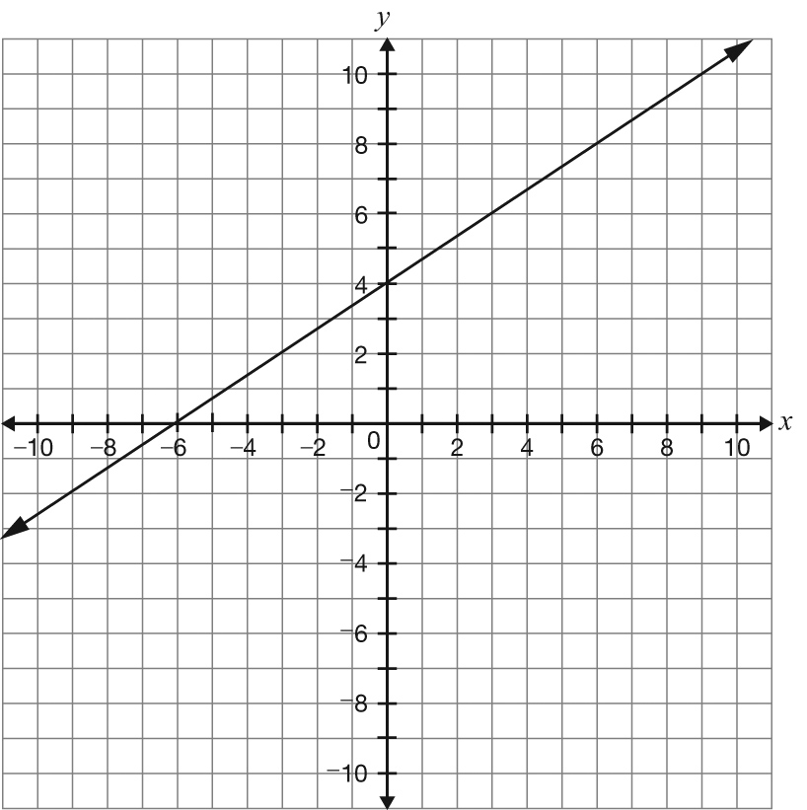

Show your work.
17 Skate On!
A diagram of a community ice rink is shown below.
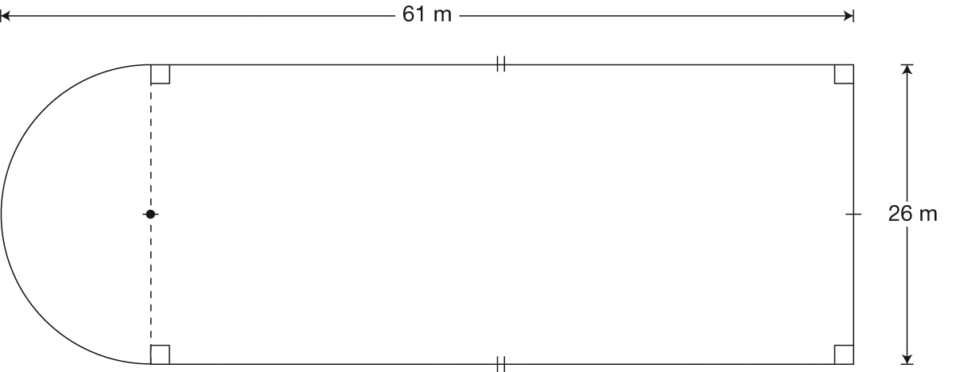

The rink is being enclosed with fencing that costs $6.20/m.
Determine the total cost of fencing for the rink.
Show your work.
18 A Schoolyard
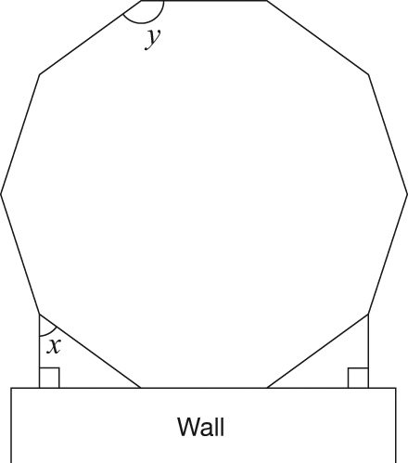
A schoolyard is in the shape of a regular decagon, as pictured below.

Complete the chart below with the values of x and y. Justify your answers using geometric properties.
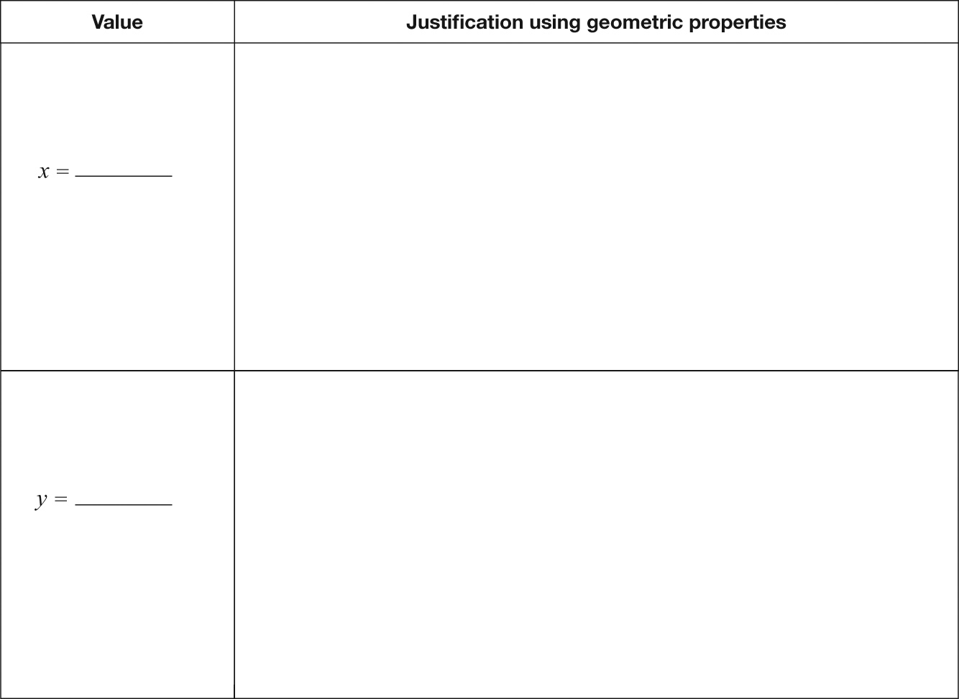

Multiple-Choice
19 Which equation does not represent a linear relation?
a y = 0
b x = 5
c x² + y = 9
d 2x + y – 5 = 0

20 What is the slope of the line represented by the equation below?
0 = 2x − 10y + 7
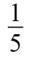
a 5
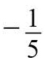
b
c
d –5

21 The end points of line segment AB are A(3, –12) and B(6, k).
What is the value of k if the slope of line segment AB is –2?
a –18
b –6
c 6
d 18

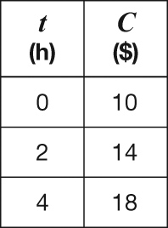
22 Information about three different relationships between C, in dollars, and t, in hours, is shown below.

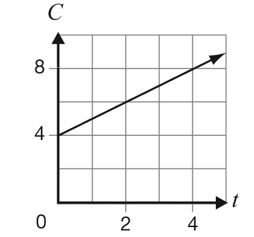

C = 4 + 0.5t

How many of the three relationships between C and t have a rate of change of $4 per hour?
a 0
b 1
c 2
d 3

23 A line passes through the point (6, 4) and has a slope of 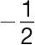.
Which of the following graphs represents this line?
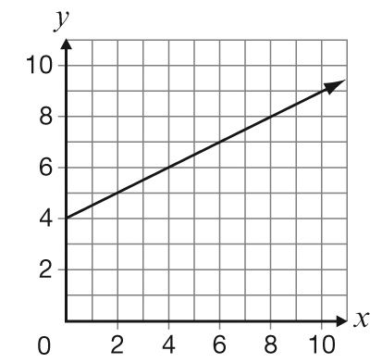
a

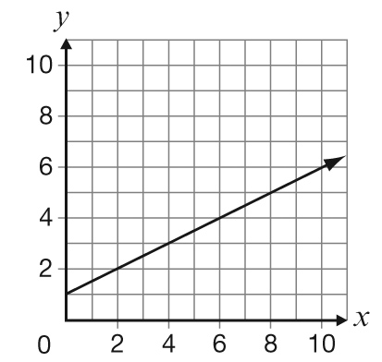
b

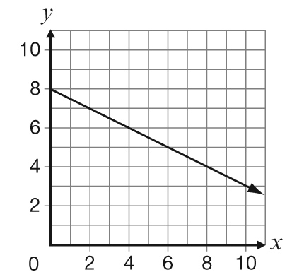
c

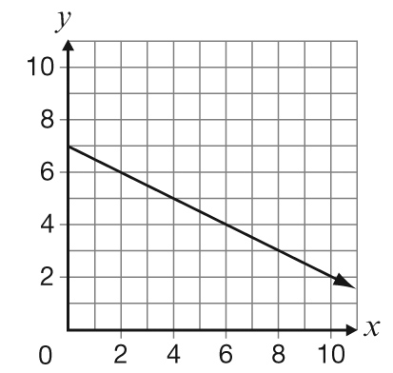
d

24 The maximum number of tickets that can be sold for a school play is 350.
The total profit earned, P, can be determined using the equation P = 4.50n – 1080, where n is the total number of tickets sold.
Which of the following statements is true?
a The maximum profit is $1080.
b The maximum profit is $1575.
c The total profit is $0 when 240 tickets are sold.
d The total profit is $0 when 350 tickets are sold.

25 Two gyms offer fitness classes. The graph below shows the total cost for the first gym.
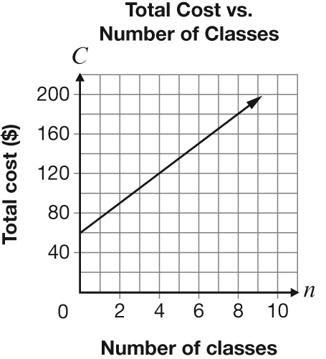

For 4 classes, both gyms have the same total cost.
Which of the following could represent the total cost for the second gym?
a C = 60 + 4n
b C = 40 + 15n
c The total cost is made up of a membership fee of $60 and $10 per class.
d The total cost is made up of a membership fee of $40 and $20 per class.

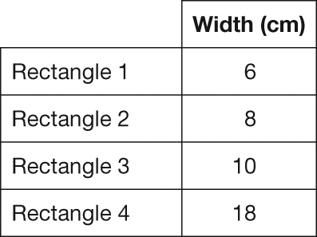
26 The table below lists the widths of four rectangles, each with an area of 72 cm².

Which rectangle has the smallest perimeter?
a Rectangle 1
b Rectangle 2
c Rectangle 3
d Rectangle 4

27 Salt is sold in packages in the shape of a rectangular-based prism that is not a cube. A new package in the shape of a cube is designed to contain the same volume.
Which of the following is true about the new package?
a It holds less salt.
b It holds more salt.
c It requires less material.
d It requires more material.

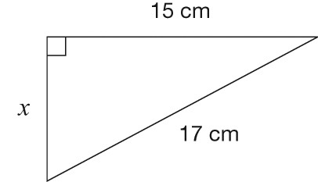
28 According to the Pythagorean theorem, what is the length of the third side of the triangle, x?

a 2 cm
b 4 cm
c 6 cm
d 8 cm

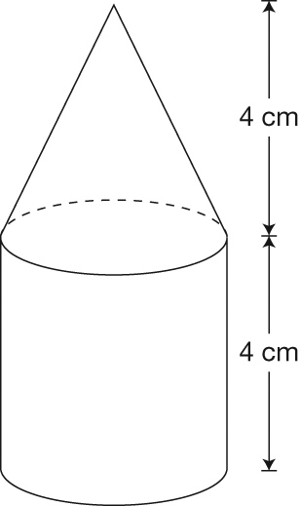
29 The figure pictured below is made up of a cone on top of a cylinder.

The cylinder has a volume of 96 cm³.
What is the volume of the figure?
a 120 cm³
b 128 cm³
c 144 cm³
d 192 cm³

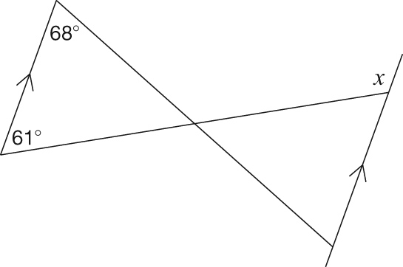
30 Consider the diagram below.

What is the value of x?
a 61°
b 68°
c 112°
d 119°

31 The following figure is a 15-sided regular polygon.
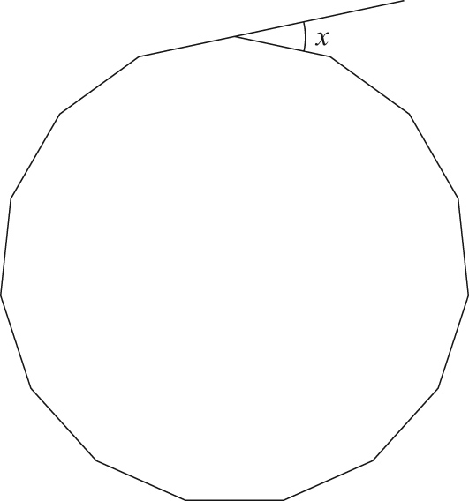

What is the value of x shown in the diagram?
a 24°
b 34°
c 46°
d 48°

